**ALTSA SFY22 Budget Reduction Exercise: Estimated Client Eligibility Cuts**

The COVID-19 pandemic has done significant damage to Washington’s economy. With state revenue collections projected to decline sharply for the foreseeable future, OFM [directed state agencies](https://ofm.wa.gov/sites/default/files/public/budget/documents/ActionsCaptureOperatingBudgetSavings.pdf) to identify options for reducing their spending. Because of maintenance of effort (MOE) requirements in the CARES Act, ALTSA cannot make eligibility, or level of benefits, while still receiving enhanced federal match. The information below provides additional detail on the modeling of eligibility reductions that could potentially begin in SFY22, ending services for approximately 12,000 ALTSA Medicaid clients. ALTSA will continue to work with DSHS and OFM to review and refine savings options for the governor and the Legislature to consider.

**NOTE: The data reflect preliminary savings related to changes in eligibility modeled in this reduction option. This is not a formal proposal and does not necessarily reflect the priorities of Gov. Inslee or ALTSA. Modeling this service reduction does not mean the reduction will actually happen, or happen at the level shown**.

**Modeling of MPC Elimination and NFLOC Eligibility Change By Setting** 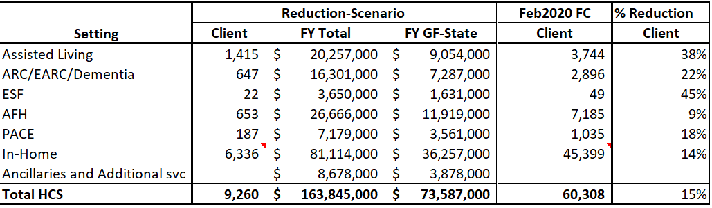

**There would be up to 2,800 people in Skilled Nursing Facilities who would no longer meet NFLOC, saving $221,848,000 ($110,924,000 GF-State) annually.**

*Ancillary Services such as nurse delegation, personal emergency response systems, behavior supports, etc. are authorized based upon assessment and these services for client no longer functionally eligible would end. The client counts are already reflected in the primary personal care settings/providers.The number of clients authorized for those ancillary services are modeled in a table below. The actual client numbers are estimates based upon an August 2020 data pull.

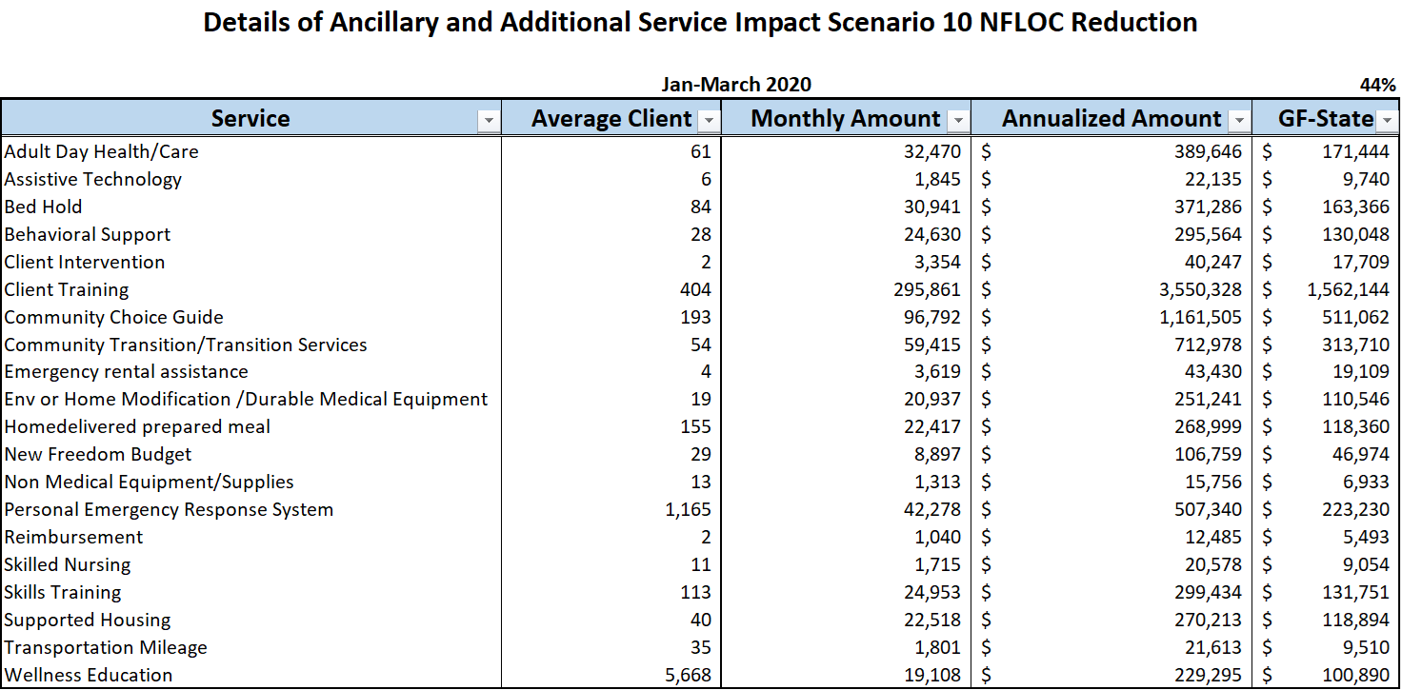

**Estimated Number of Clients by CARE Classification Group that would lose eligibility based upon this model of eligibility cut based upon August 2020 data pull.**

|  |  |  |  |  |  |  |  |  |  |
| --- | --- | --- | --- | --- | --- | --- | --- | --- | --- |
| **Acuity Order** | **Acuity** | **Assisted Living** | **ARC/EARC/ Dementia ECS** | **ESF** | **PACE** | **AFH** | **HC Agencies** | **Individual Provider** | **Total** |
| 1 | A Low | 790 | 115 |  | 78 | 55 | 523 | 336 | 1,893 |
| 2 | B Low | 298 | 368 | 21 | 45 | 366 | 896 | 573 | 2,562 |
| 3 | A Med | 199 | 39 |  | 26 | 18 | 747 | 711 | 1,732 |
| 4 | B Med | 73 | 78 | 1 | 26 | 151 | 934 | 916 | 2,147 |
| 5 | C Low | 41 | 17 | 0 | 6 | 9 | 123 | 83 | 277 |
| 6 | A High | 7 | 1 |  | 3 | 3 | 102 | 130 | 244 |
| 7 | D Low | 2 |  |  | - | 2 | 1 | 6 | 11 |
| 8 | B Med-High | 2 | 17 |  | 2 | 25 | 8 | 23 | 77 |
| 9 | B High | 1 | 10 |  | - | 15 |  | 9 | 35 |
| 10 | C Med | 2 | 2 |  | 1 | 9 | 141 | 134 | 281 |
| 11 | D Med |  |  |  |  |  |  | - | - |
| 12 | C Med-High |  |  |  |  |  |  | 1 | 1 |
| **TOTAL** |  | **1,415** | **647** | **22** | **187** | **653** | **3,475** | **2,922** | **9,260** |

|  |  |  |  |
| --- | --- | --- | --- |
| **Annual Staffing Reductions due to potential functional eligibility changes: Assuming roughly 9,300 clients lose services and need for case management and financial eligibility maintenance** | **Biennial FTE** | **Biennial GF-S** | **Biennial Total Funds** |
| AAA |  | $8,505,000 | $17,682,000 |
| HCS | 69.6 | $8,111,000 | $16,218,000 |

**The eligibility reduction that was modeled for this budget exercise would:**

* Eliminate the MPC program.
* Change the NFLOC eligibility model to increase the functional impairment level required for eligibility in the following ways:
  + The method that previously required an unmet need with at least three ADLs is changed to require an unmet need with at least four ADLs. Supervision and set up assistance only would not be considered.
  + The method that previously required an unmet need with at least two ADLs is increased to at least three ADLs. Assistance that didn’t occur because there was no provider available would not be considered for some ADLs. When Medication Management is one of the ADLs identified, it has changed from requiring assistance at any frequency to needing daily assistance.
  + The method that previously required an unmet need with at least one ADL in addition to a cognitive impairment would not change in relation to the ADL needs; however, the data elements that compose identification of “cognitive impairment” have changed.
  + Removes the ability for a client to decline assistance and become eligible.
  + Narrows the situations where a client can become eligible because an activity didn’t occur because they didn’t have a caregiver but would have accepted assistance if they had a caregiver.
* Statute requires that if cuts are necessary that they be done in a way that impacts the least needy first. Nursing Facility Level of Care is determined through unmet need for assistance with activities of daily living and daily nursing need. In this eligibility cut, individuals with a lower level of unmet need for activities of daily living are impacted which may include individuals whose need for personal care services are related to supervision and cueing. The population that this most impacts includes individuals whose need for services is primarily due functional impairments due to behavioral health, Traumatic Brain Injury, early diagnoses of dementia, etc.

**ALTSA SFY22 Budget Reduction Exercise: Estimated Client Eligibility Cuts – 2.4%**

|  |  |  |  |  |  |  |  |  |
| --- | --- | --- | --- | --- | --- | --- | --- | --- |
| **FY22 Provider Rate Cuts of 2.4% (Based Upon Summer 2020 Forecast)** | | | | | | | | |
| **ALTSA** | **Caseload** | **Per Cap** | **State %** | **Federal %** | **Per  Cap Reduction** | **State Savings** | **Federal Savings** | **Total Savings** |
| Adult Day Health | 764 | 741 | 50.0% | 50.0% | (18) | (82,000) | (82,000) | (164,000) |
| Adult Family Homes | 8,535 | 3,705 | 46.1% | 53.9% | (89) | (4,199,000) | (4,908,000) | (9,107,000) |
| Adult Residential Care | 3,381 | 2,711 | 47.7% | 52.3% | (65) | (1,259,000) | (1,381,000) | (2,640,000) |
| Assisted Living | 3,640 | 1,345 | 46.7% | 53.3% | (32) | (659,000) | (751,000) | (1,410,000) |
| Agency Providers | 15,950 | 2,286 | 43.8% | 56.2% | (55) | (4,600,000) | (5,900,000) | (10,500,000) |
| Individual Providers | 32,222 | 2,818 | 43.8% | 56.2% | (68) | (11,457,000) | (14,693,000) | (26,150,000) |
| Managed Care | 1,156 | 2,747 | 49.4% | 50.6% | (66) | (452,000) | (463,000) | (915,000) |
| Nursing Homes | 9,392 | 7,022 | 49.0% | 51.0% | (169) | (9,303,000) | (9,690,000) | (18,993,000) |
| Private Duty Nursing | 132 | 18,391 | 50.1% | 49.9% | (441) | (350,000) | (348,000) | (698,000) |
| ESF | 156 | 455 | 50.4% | 49.6% | (11) | (10,000) | (10,000) | (20,000) |
| **Total** |  |  |  |  |  | **(32,371,000)** | **(38,226,000)** | **(70,597,000)** |